**Online Retail Billing System**

**GROUP – 3**

**TABLE OF CONTENTS**

|  |  |  |
| --- | --- | --- |
| S.No | TOPIC | Page No |
| 1 | Table of contribution | 2 |
| 2 | Java Code | 3-14 |
| 3 | Outputs | 15-18 |

**TABLE OF CONTRIBUTION**

|  |  |  |
| --- | --- | --- |
| Name | Roll no | Contribution |
| **Aashika B S** | CB.SC.I5DAS19003 | CSV FILE creation and retrieval in java, Main class creation |
| **Krithiga M** | CB.SC.I5DAS19020 | Random discount generator, multiple inheritance creation |
| **Shivada K P** | CB.SC.I5DAS19028 | Bill generator in each category. |

**Note:**

As we have included a CSV file in our java code, we have given local address of the CSV file to retrieve the data in NetBeans and also it does not work on online compiler because the csv file is present locally in the computer.

The csv file is attached in the folder.

**JAVA CODE:**

import java.util.*;

import java.io.*;

import au.com.bytecode.opencsv.CSVReader;

class welcome{

void greeting(){

System.out.println("\n" + "WELCOME TO ONLINE RETAIL SYSTEM" + "\n" + "Your satisfaction is our improvement.");

Scanner scanner = new Scanner(new File("C:\\Users\\Balakrishanan\\Documents\\CSVDemo.csv"));

scanner.useDelimiter(",");

System.out.println();

while (scanner.hasNext())

{

System.out.print(scanner.next() + " ");

}

//Do not forget to close the scanner

scanner.close();

}

}

class Categories extends welcome{

void storeselection(){

System.out.println("1.Stationary 2.Essentials 3.Groceries 4.Fruits 5.Clothes 6.To exit");

}

}

class retailshopbilling extends Categories{

public void StationaryItems() {

int total=0;

while (true){

Scanner sc = new Scanner(System.in);

System.out.println("1.Pen 2.Pencil 3.Ruler 4.Eraser 5.Sharpener 6.Pay bill");

System.out.println("Enter nos 1 to 5 to purchase accordingly");

int product=sc.nextInt();

if(product==1){

int price=20;

System.out.println("Enter quantity in boxes (10 pcs/box)");

int quantity=sc.nextInt();

total+=(quantity*price);

}

else if(product==2){

int price=30;

System.out.println("Enter quantity in boxes (10 pcs/box)");

int quantity=sc.nextInt();

total+=(quantity*price);

}

else if(product==3){

int price=30;

System.out.println("Enter quantity in boxes (10 pcs/box)");

int quantity=sc.nextInt();

total+=quantity*price;

}

else if(product==4){

int price=30;

System.out.println("Enter quantity in boxes (10 pcs/box)");

int quantity=sc.nextInt();

total+=quantity*price;

}

else if(product==5){

int price=30;

System.out.println("Enter quantity in boxes (10 pcs/box)");

int quantity=sc.nextInt();

total+=quantity*price;

}

else if(product==6){

System.out.println("Your Stationary bill :"+total);

Scanner input = new Scanner(System.in);

System.out.println("Enter total amount to pay the bill: ");

int status = input.nextInt();

if (status==total){

System.out.println("Your order is placed");

break;

}

else{

System.out.println("Please pay the bill to place order.");

}

}

else{

System.out.println("Enter a valid option!!");

}

}

}

public void Essentials(){

int total=0;

while(true){

Scanner sc = new Scanner(System.in);

System.out.println("1.Bath soap 2.Shampoo 3.Toothpaste 4.Napkin 5.Sanitizer 6.Pay bill");

System.out.println("Enter nos 1 to 5 to purchase accordingly");

int product=sc.nextInt();

if(product==1){

int price=20;

System.out.println("Enter quantity: ");

int quantity=sc.nextInt();

total+=quantity*price;

}

else if(product==2){

int price=80;

System.out.println("Enter quantity: ");

int quantity=sc.nextInt();

total+=quantity*price;

}

else if(product==3){

int price=40;

System.out.println("Enter quantity: ");

int quantity=sc.nextInt();

total+=quantity*price;

}

else if(product==4){

int price=70;

System.out.println("Enter quantity: ");

int quantity=sc.nextInt();

total+=quantity*price;

}

else if(product==5){

int price=40;

System.out.println("Enter quantity: ");

int quantity=sc.nextInt();

total+=quantity*price;

}

else if(product==6){

System.out.println("Your Essentials bill :"+total);

Scanner input = new Scanner(System.in);

System.out.println("Enter total amount to pay the bill: ");

int status = input.nextInt();

if (status==total){

System.out.println("Your order is placed");

break;

}

else{

System.out.println("Please pay the bill to place order.");

}

}

else{

System.out.println("Enter a valid option!!");

}

}

}

public void Groceries() {

int total=0;

while (true){

Scanner sc = new Scanner(System.in);

System.out.println("1.Bread 2.Cheese 3.Eggs(6/box) 4.Rice(1kg) 5.Chicken 6.Pay bill");

System.out.println("Enter nos 1 to 5 to purchase accordingly");

int product=sc.nextInt();

if(product==1){

int price=20;

System.out.println("Enter quantity: ");

int quantity=sc.nextInt();

total+=quantity*price;

}

else if(product==2){

int price=30;

System.out.println("Enter quantity: ");

int quantity=sc.nextInt();

total+=quantity*price;

}

else if(product==3){

int price=12;

System.out.println("Enter quantity: ");

int quantity=sc.nextInt();

total+=quantity*price;

}

else if(product==4){

int price=29;

System.out.println("Enter quantity: ");

int quantity=sc.nextInt();

total+=quantity*price;

}

else if(product==5){

int price=30;

System.out.println("Enter quantity: ");

int quantity=sc.nextInt();

total+=quantity*price;

}

else if(product==6){

System.out.println("Your Groceries bill :"+total);

Scanner input = new Scanner(System.in);

System.out.println("Enter total amount to pay the bill: ");

int status = input.nextInt();

if (status==total){

System.out.println("Your order is placed");

break;

}

else{

System.out.println("Please pay the bill to place order.");

}

}

else{

System.out.println("Enter a valid option!!");

}

}

}

public void Fruits() {

int total=0;

while(true){

Scanner sc = new Scanner(System.in);

System.out.println("(per 500g) 1.Apple 2.Orange 3.Strawberry 4.Banana(6 pieces) 5.Pineapple(1) 6.Pay bill");

System.out.println("Enter nos 1 to 5 to purchase accordingly");

int product=sc.nextInt();

if(product==1){

int price=25;

System.out.println("Enter quantity: ");

int quantity=sc.nextInt();

total+=quantity*price;

}

else if(product==2){

int price=30;

System.out.println("Enter quantity: ");

int quantity=sc.nextInt();

total+=quantity*price;

}

else if(product==3){

int price=40;

System.out.println("Enter quantity: ");

int quantity=sc.nextInt();

total+=quantity*price;

}

else if(product==4){

int price=30;

System.out.println("Enter quantity: ");

int quantity=sc.nextInt();

total+=quantity*price;

}

else if(product==5){

int price=40;

System.out.println("Enter quantity: ");

int quantity=sc.nextInt();

total+=quantity*price;

}

else if(product==6){

System.out.println("Your Fruits bill :"+total);

Scanner input = new Scanner(System.in);

System.out.println("Enter total amount to pay the bill: ");

int status = input.nextInt();

if (status==total){

System.out.println("Your order is placed");

break;

}

else{

System.out.println("Please pay the bill to place order.");

}

}

else{

System.out.println("Enter a valid option!!");

}

}

}

public void Clothes() {

int total=0;

while(true){

Scanner sc = new Scanner(System.in);

System.out.println("1.Tshirt 2.Shirt 3.Jeans 4.Dress 5.Saree 6.Pay bill");

System.out.println("Enter nos 1 to 5 to purchase accordingly");

int product=sc.nextInt();

if(product==1){

int price=500;

System.out.println("Enter quantity ");

int quantity=sc.nextInt();

total+=quantity*price;

}

else if(product==2){

int price=400;

System.out.println("Enter quantity");

int quantity=sc.nextInt();

total+=quantity*price;

}

else if(product==3){

int price=700;

System.out.println("Enter quantity ");

int quantity=sc.nextInt();

total+=quantity*price;

}

else if(product==4){

int price=800;

System.out.println("Enter quantity ");

int quantity=sc.nextInt();

total+=quantity*price;

}

else if(product==5){

int price=3000;

System.out.println("Enter quantity");

int quantity=sc.nextInt();

total+=quantity*price;

}

else if(product==6){

System.out.println("Your Clothes bill :"+total);

Scanner input = new Scanner(System.in);

System.out.println("Enter total amount to pay the bill: ");

int status = input.nextInt();

if (status==total){

System.out.println("Your order is placed");

break;

}

else{

System.out.println("Please pay the bill to place order.");

}

}

else{

System.out.println("Enter a valid option!!");

}

}

}

public void voucher() {

String[] arr={"You have received a voucher worth ₹200. Valid upto 23-12-2021.",

"Get flat 20% on purchase at our stationary store. Redeem today.",

"Get flat 10% off on Essentials. Valid upto 20-12-2021.",

"Try our new product samples for free. Redeem Today.",

"Mystery flash offer valid until this sunday!" + "\n" + "Choose one symbol out of the three:" + "\n" + " ! & ?" + "\n" + "and win exciting prices."};

Random r=new Random();

int randomNumber=r.nextInt(arr.length);

System.out.println("Your discount is :"+arr[randomNumber]);

System.out.println("Thankyou for purchasing. Come again.");

}

}

public class Hello{

public static void main(String args[]){

while(true){

retailshopbilling t = new retailshopbilling();

Scanner sc = new Scanner(System.in);

t.greeting();

t.storeselection();

System.out.println("Enter choice :");

int x = sc.nextInt();

if(x==1){

t.StationaryItems();

t.voucher();

}

else if(x==2){

t.Essentials();

t.voucher();

}

else if(x==3){

t.Groceries();

t.voucher();

}

else if(x==4){

t.Fruits();

t.voucher();

}

else if(x==5){

t.Clothes();

t.voucher();

}

else if(x==6){

break;

}

else{

System.out.println("Wrong choice");

}

}

}

**Outputs:**

**CLASS Welcome(**This class displays the CSV CONTENTS.)

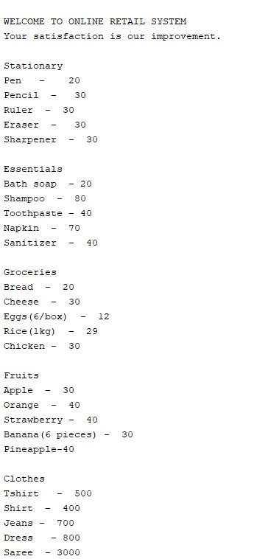

**CLASS Retailshopbilling:**

* **Stationary purchase with bill generation and random discount vouchers**

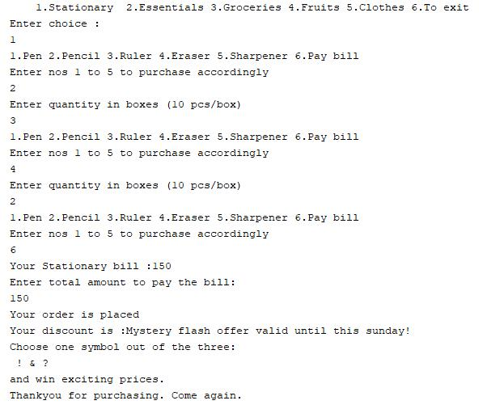

* **Essentials purchase with bill generation and random discount vouchers**

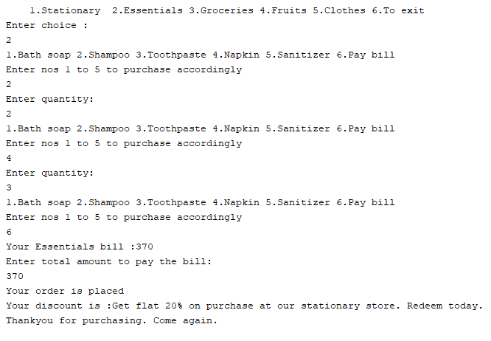

* **Groceries purchase with bill generation and random discount vouchers**

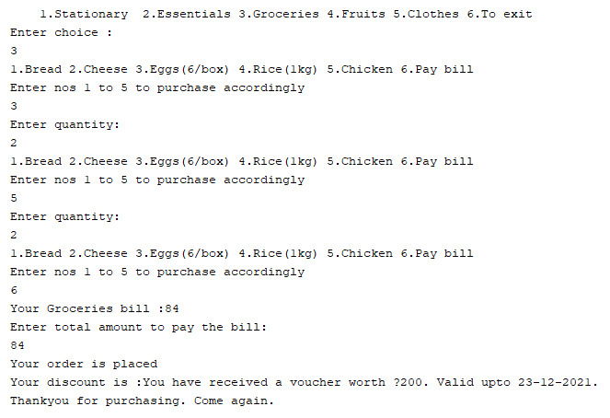

* **Fruits purchase with bill generation and random discount vouchers**

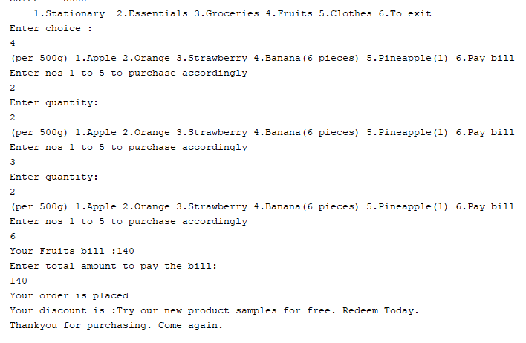

* **Clothes purchase with bill generation and random discount vouchers**

